Photos from Mr. Itagaki in Philippines 2015 July 3rd.

Angat Dam
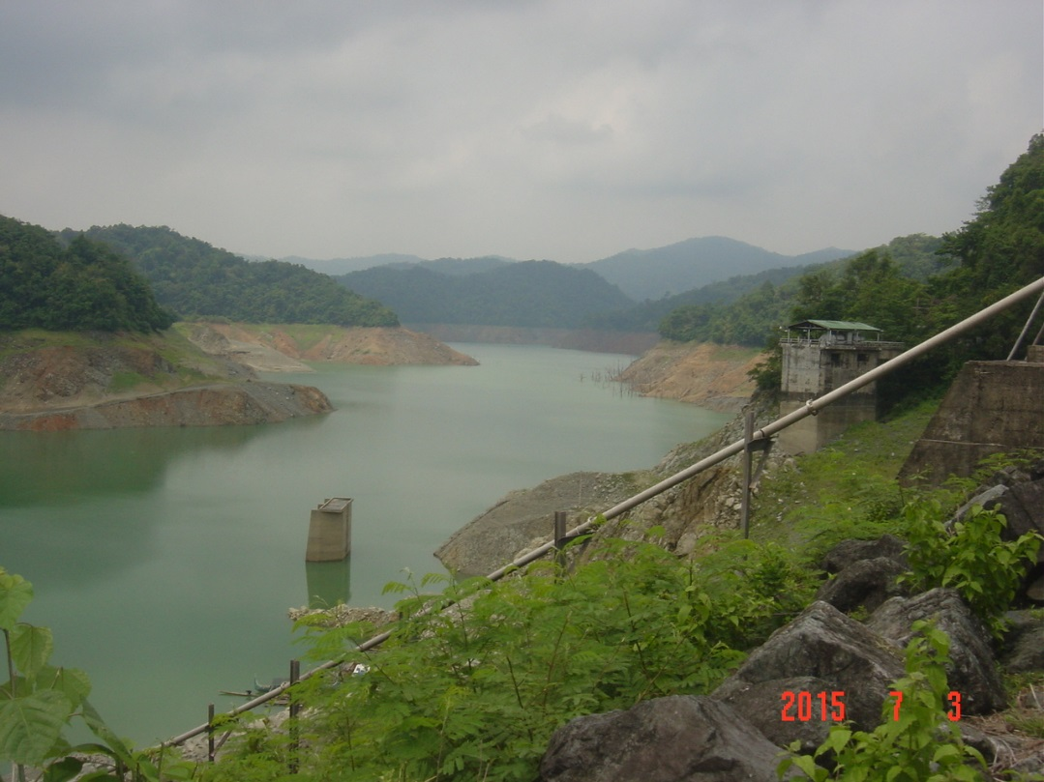

Ipo Dam
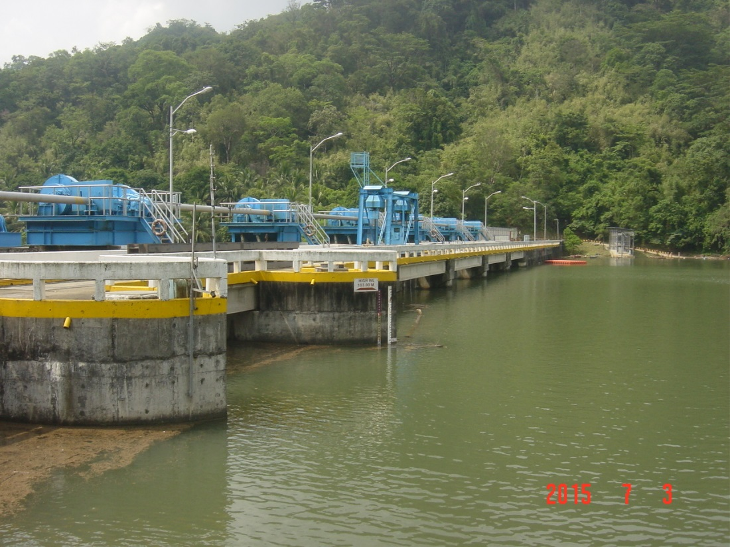

Bustos Dam
